# **From a Friend - Vol. 1**

Apr 02, 2025

1

[1](https://femmefuturescooperative.substack.com/p/from-a-friend-vol-1/comments)

1

Share

*Hi guys,*

*I am trying something new today, and no, it’s not just being in your inbox on a Wednesday. A friend of mine was kind enough to share her thoughts on navigating the corporate world as a do-gooder. Her essay speaks to working in tech and navigating being a salesperson while having conflicting feelings about capitalism, as well as the art and humanity of connection — even in commercial spaces. I hope that you enjoy it as much as I did.*

*Best,*

*Zoe*

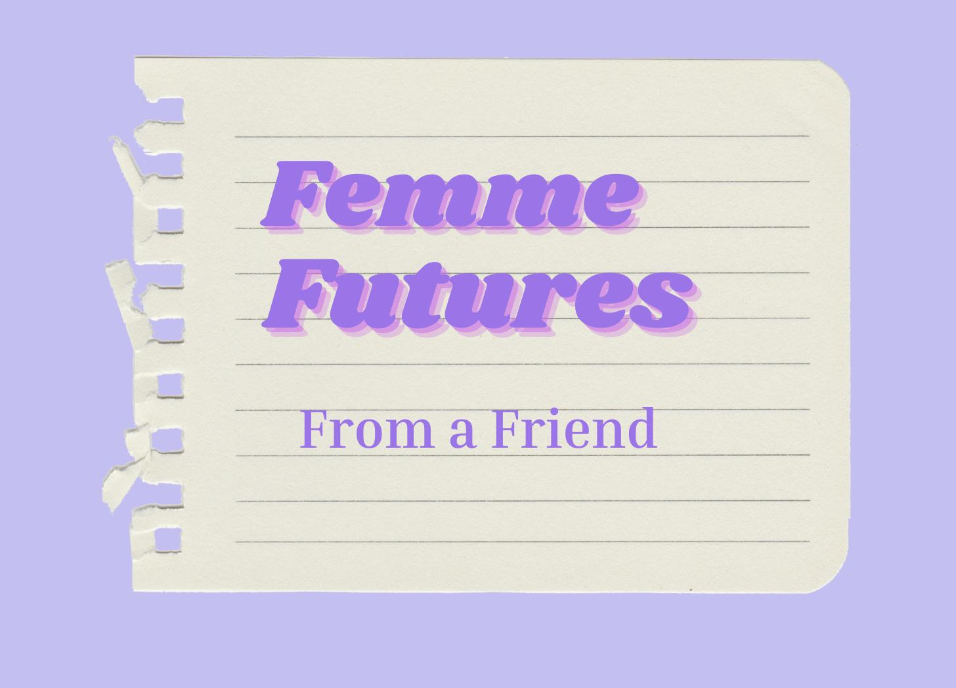

Before I go any further — let’s do the housekeeping.

First, if you are not already a subscriber and you resonate with any of the following descriptors, consider joining the cooperative: (1)Early-career professional; (2) Feminist; (3) Do-Gooder; (4) Former Gifted Kid; (5) Overachiever; or (6) Capitalism-hater.

Subscribed

Second, if you like what I am saying and it makes you think of someone in your family/office/friend group, send it their way.

[Share Femme Futures Cooperative](https://femmefuturescooperative.substack.com/?utm_source=substack&utm_medium=email&utm_content=share&action=share)

Third, I say some personal and vulnerable shit every week. Say some vulnerable shit back. It’s called a community.

[Leave a comment](https://femmefuturescooperative.substack.com/p/from-a-friend-vol-1/comments)

Okay — back to it.

Hey Zoe!

*Your invitation to write for Femme Futures took me down a lot of roads. I ended up focusing on a topic I think most young adults and Severance fans have thought about: how to be a human at work.*

My favorite class in college was a seminar entitled “Truth, Virtue, and Friendship” (insert hand wanking motion). Every Thursday I sat with my fellow deluded twenty-year-olds and discussed how to live a meaningful life. As you can imagine, we frequently found ourselves in high-strung debates. One such back-and-forth has never left my brain: is it wrong to network? I.e. is it wrong to initiate a relationship with someone while secretly, or not so secretly, harboring a motive?

I distinctly remember being torn on the topic and since then, I’ve turned this debate over in my head a thousand times. It represents for me a dissonance that I believe most working people, especially those early in our careers, feel: there is one part of you that wants to pursue things for their pure purpose and the other that has been trained to extract gain anywhere you can manage to. Let me describe one of my dissonances: I’m hosting a work event for customers (that I’d like to believe is simply aimed at connection and learning) and an attendee mentions a recent struggle. My brain then dings with excitement – I know something that could help! And then comes the crash…it costs money. Am I really about to pitch to this guy? I’m then reminded that my job is not as purely motivated as I would like it to think it is.

This is an incredibly obvious aspect of the working world and this realization is *so* 23-years-old of me. But alas, it stings. I began work as an event planner in college where I was tasked with planning events aimed at creating a sense of belonging. Those random pumpkin painting workshops on a college campus? Yeah, those were my bread and butter. My first job out of college was at a non-profit where I could very easily separate myself from the fundraising side since someone else (who was making way bigger bucks than me) was in charge of it. Now though, I work in the tech community space where I am a representative of the company and I am compelled to create events that build customer loyalty and will result in further investment.

So there I was in the great city of Buckhead, Georgia feeling like I needed to take a shower. How had the event planner in me that waxed so poetically about the importance of connection and belonging just try to tee up a sales pitch? And if I am to do so, is it going against my personal mandate to inspire connection?

There is definitely a longer essay here about how our modern life and economic system distort everything’s inherent purpose and then numbs us to the dissonance therein. But for the time being, I want to focus on a few things I’ve seen and tried that will allow me (or you!) to maintain my authenticity and personal purpose of connection while keeping with my goal to increase NRR[1](https://femmefuturescooperative.substack.com/p/from-a-friend-vol-1#footnote-1-160062736).

Like I said, I work in the tech community industry which is a powerful tool for ensuring users are invested in your product. Recently, I’ve seen the impact of creating a dialogue with community members. I now end each event with the same questions: *What about this meeting was helpful? What do you want to see next? Do you want to present?* It reminds them that I am not there to create experiences that hypnotize them into signing a contract. I want to help them better understand and engage with the software to make their jobs easier and ensure they advance in their careers. Everybody wins!

Additionally, I’ve historically felt that this dynamic is the elephant in the room that creates an awkward heaviness in my conversations. Through more and more customer conversations, I’ve come to my senses. I am working with adults who were not born yesterday; they are aware that they are engaging with a business and don’t see the prospect <> company relationship as the end of polite society. For instance, I reached out to a top community contributor to thank him for doing *a lot* of unpaid labor. I was initially apprehensive to call out this detail as I was fearful (narrator: she was delusional) that by naming it he would wake up, smell the roses, and stop. After a couple drafts, I instead decided to emphasize it. His response? In summary, *I wanted this information when I was just starting out. I'm happy to help others.* People are aware and more genuine than you think.

Lastly, and this one goes hand in hand with being direct, I’ve noticed that an ask must have context. By emphasizing why they are being reached out to, you allow the individual to visualize the impact they can have. I recently was CC’ed on an email from a family friend who was boosting a recent grad’s resume and I thought the way she ended it was so apt: “Just as people helped us get our first jobs, I hope you will help Jane. Anyone who hires her will be incredibly grateful.” Boom! An ask I would’ve probably blown off is now a must-do because I know it's coming from a sincere place.

It is inevitable while in the working world to find yourself pitching and selling and selling and pitching. It can feel unappetizing and stressful but it's necessary to make peace with it. Overall, I hope my recent recalibration will allow me to efficiently do my work while not losing the distinctly human part of me. Hopefully, once the revolution does come, there'll be a bit of humanity left in me to pull from (wink).

All the best,

Your friend



Get more from Zoe in the Substack app

Available for iOS and Android

[Get the app](https://substack.com/app/app-store-redirect?utm_campaign=app-marketing&utm_content=author-post-insert&utm_source=femmefuturescooperative)

[1](https://femmefuturescooperative.substack.com/p/from-a-friend-vol-1#footnote-anchor-1-160062736)

NRR is a tech term that means “net revenue retention”